## Namadgi-3 is fitted with a bow thruster. To operate the bow thruster:

* Turn on the bow thruster isolator switch - inside the hanging cabinet in the forward starboard cabin. Turn it on well before attempting to berth the boat.

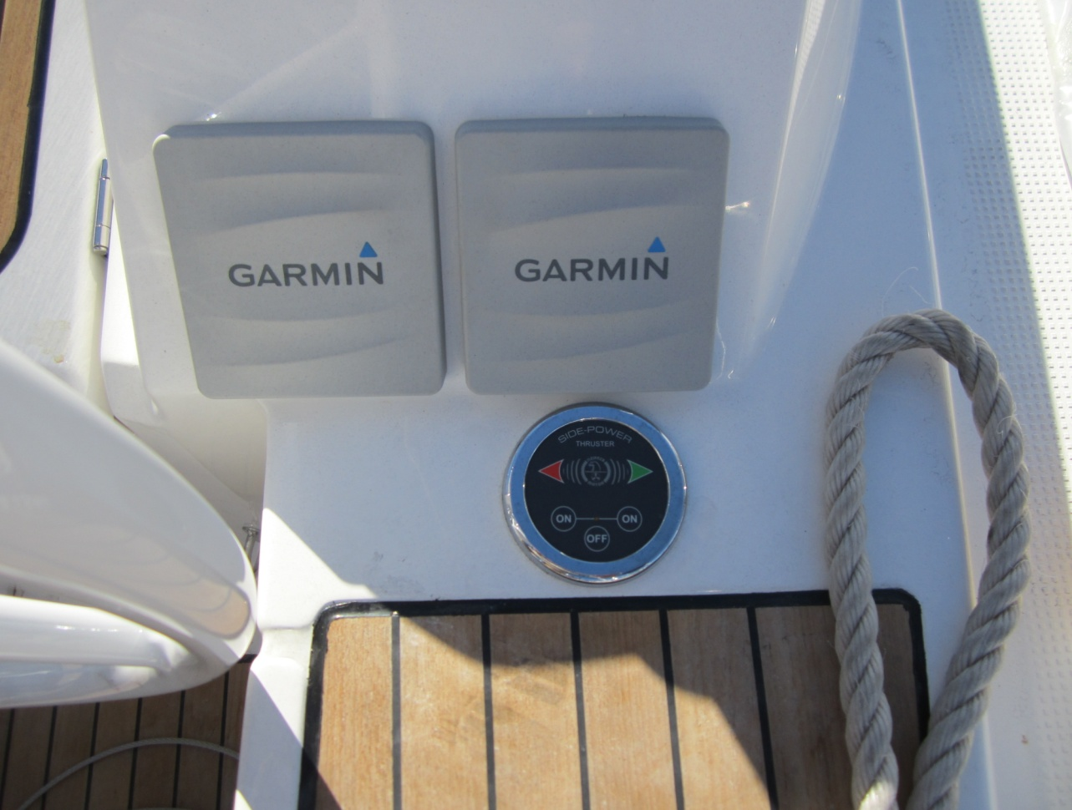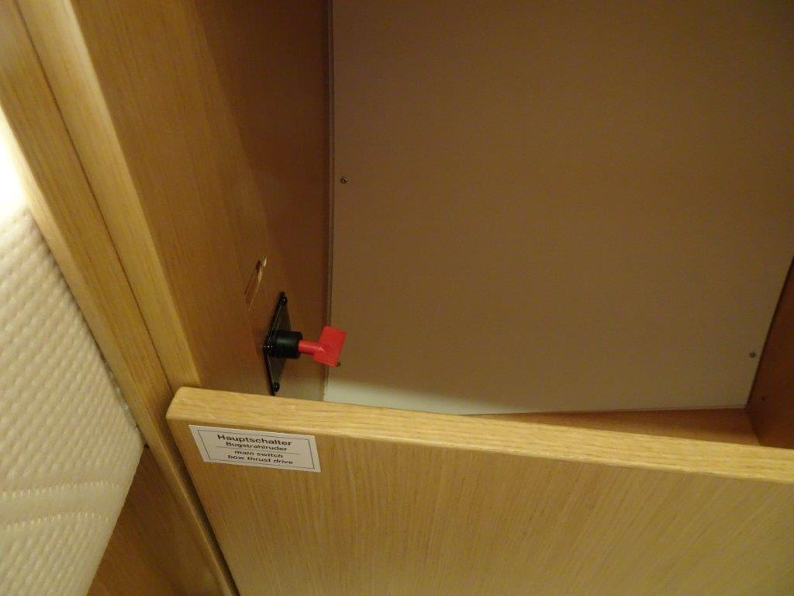

On the cockpit control at the starboard wheel:

* Engage the bow thruster by pressing the Port On and Starboard On buttons together
* Move the boat by pressing the Port or Starboard arrow in the direction you want the bow to move.
* Press the Off button to disengage the thruster.
* The bow thruster will disengage after 5 minutes. This means you will have to press both On buttons again for it to work.
* The bow thruster battery capacity is 90Ah. It is located under the starboard forward cabin bunk. It is also the anchor windlass battery.
* The bow thruster control is at the starboard helm station.
* Use the bow thruster in short bursts sparingly. Do not run it continuously.
* Be aware and brief your crew that any line or debris in the water can be ingested by the bow thruster and seriously damage the bow thruster and possibly threaten the integrity of the yacht.